Lab 1 report

By Christopher Tait (s3899475)

# Introduction

In this lab, students learned to build and simulate circuits using Altium Designer. The circuits will be simulated in the time and frequency domains to check their response against manually calculated values.

# Results and Discussion

The following figure displays the first circuit build in Altium designer

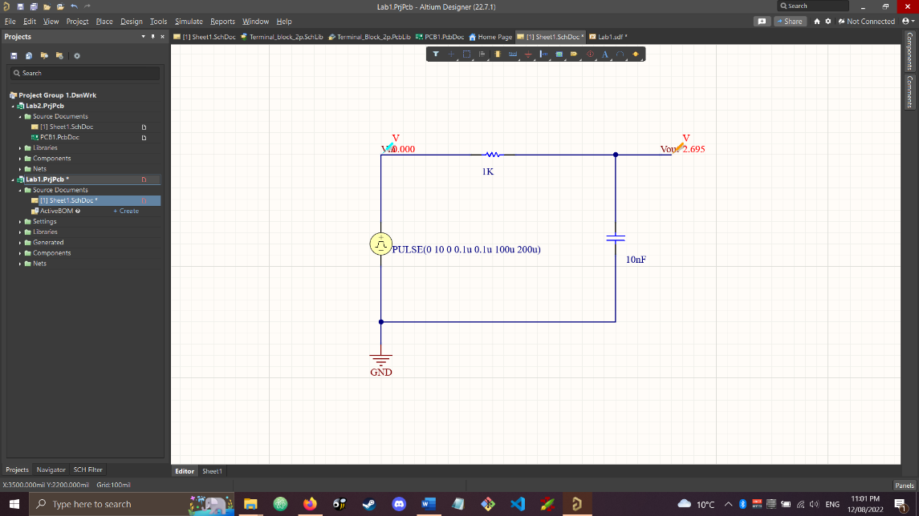

Figure 1: RC Circuit in Altium Designer

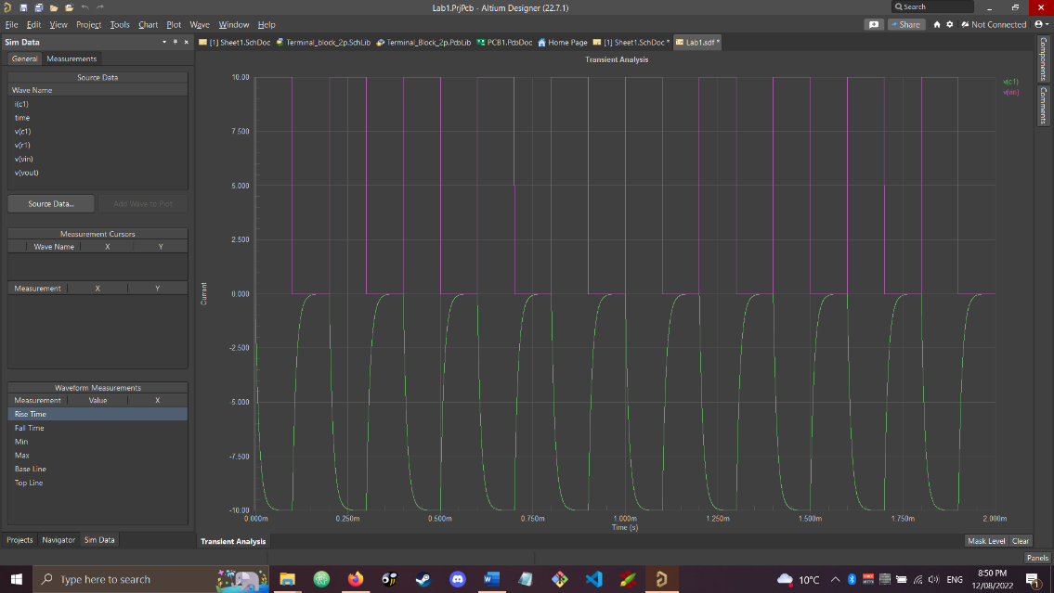

Figure 2: Transient analysis of the circuit showing the voltage across the capacitor and the input voltage

In this figure it can be clearly seen that the frequency of the voltage across the capacitor is the same as the input voltage frequency.

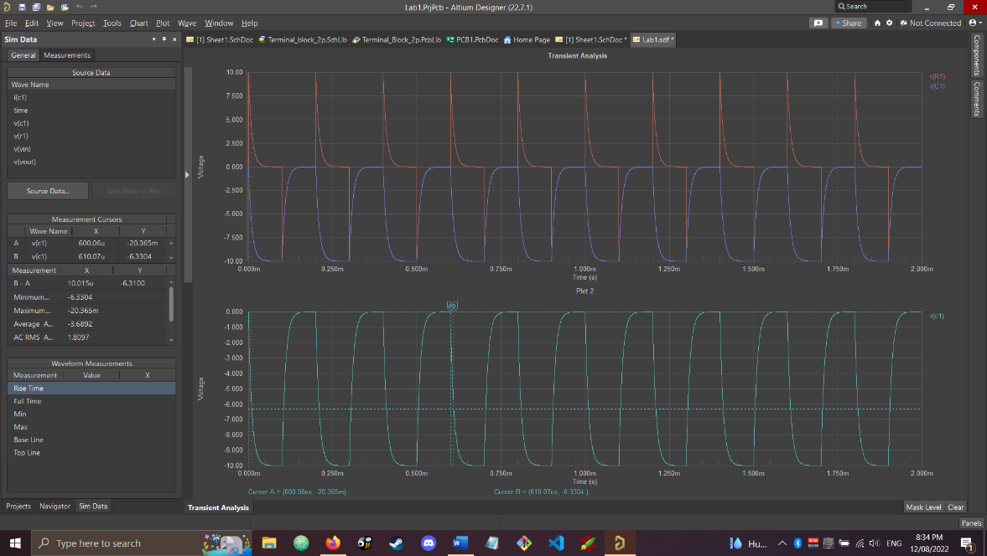

Figure 3: Transient analysis of circuit showing voltage over resistor and capacitor

As can be seen in the bottom plot of figure 2, cursors have been placed at the capacitor’s maximum voltage (near 0V) and at 63% of the final value (-10V). From the difference in time between these two cursors, it was calculated that the time constant for this circuit is 10.15 µs.

This fits with the equation from theory that the time constant should be:

Using the cursors on the capacitor voltage graph, it was found that the 10-90% rise time was 21.927µs. This fits the theoretical value of 2.2τ

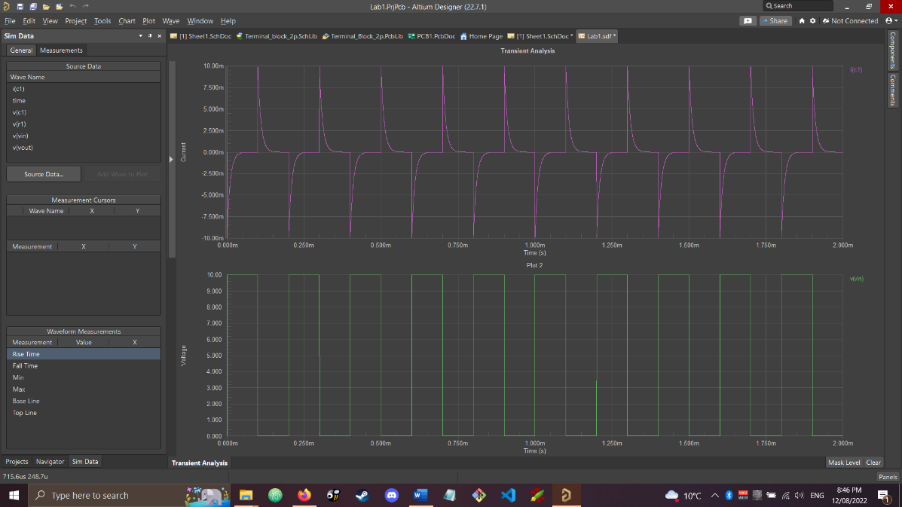

Figure 4: Transient analysis of the circuit showing the current across the capacitor and the input voltage waveform

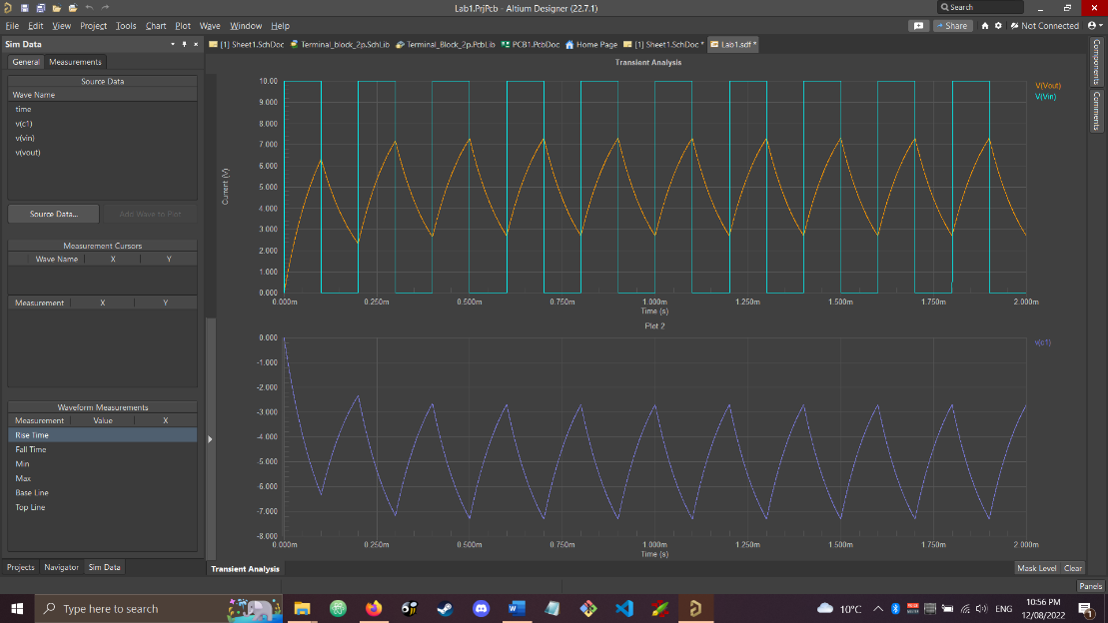

Figure 5: Transient simulation with 100nF Capacitor

The 100 nF Capacitor takes a lot longer to charge and discharge, as can be seen in the above figure. It takes to long that it does not fully charge or discharge, so it does not reach 10V. The first few waves outputted are different as the capacitor has been fully discharged before this point.

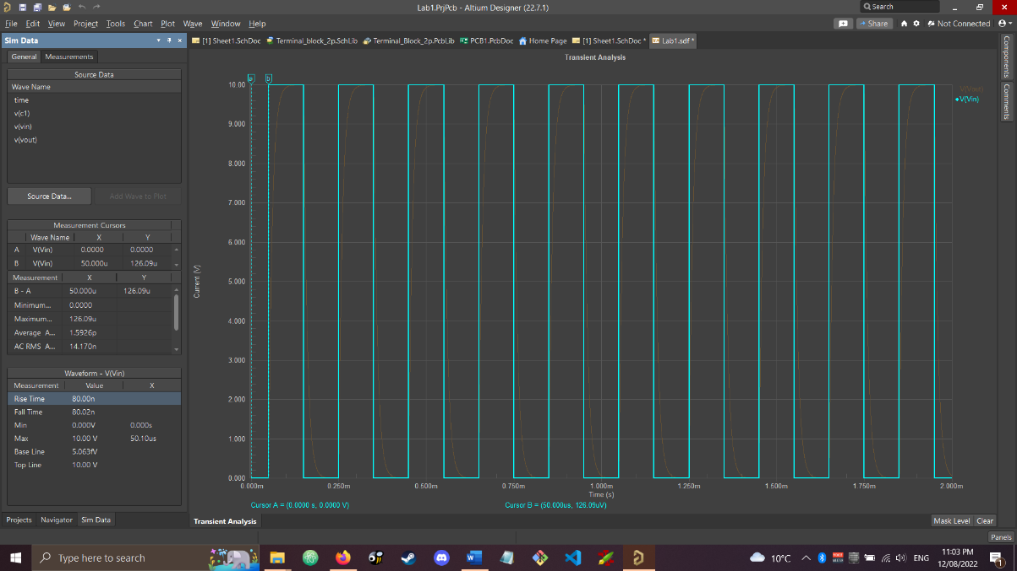

Figure 6: Transient simulation with 50 µs delay

As can be seen in this figure, setting the initial delay on the voltage source has shifted the input voltage to the right by 50 µs.

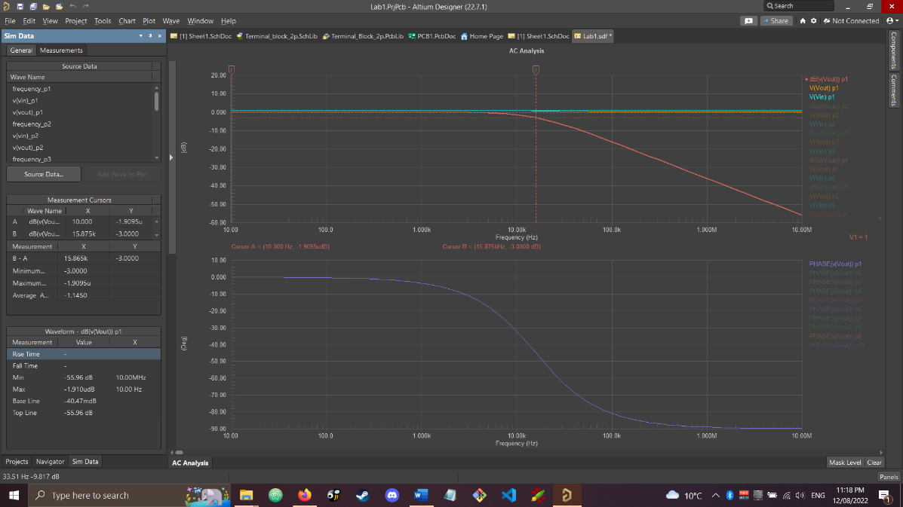

Figure 7: AC Sweep simulation of the circuit

Using the cursors in this simulation, it was found that the cut-off frequency was at 15.875 kHz. This is quite close to the theoretical cut-off frequency.

## Second order circuit RLC response

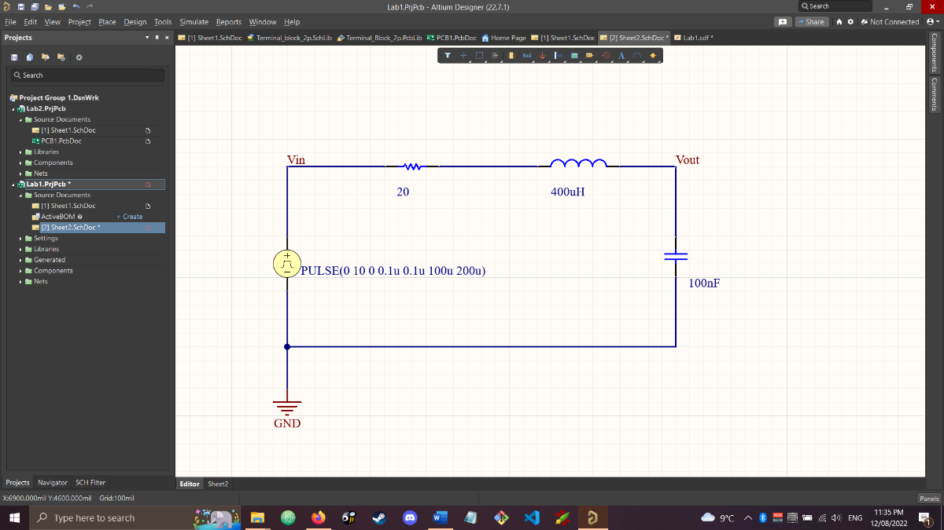

Figure 8: The RLC circuit built in Altium Designer

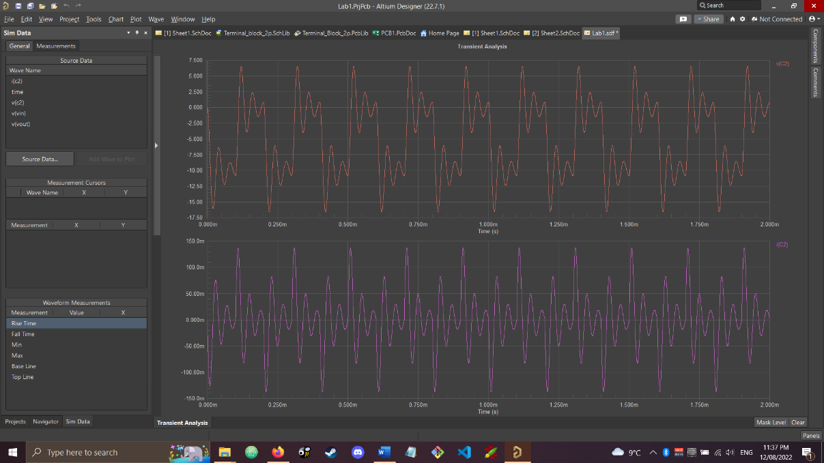

Figure 9: Transient simulation showing the voltage and current across the capacitor

Resonant frequency of the circuit:

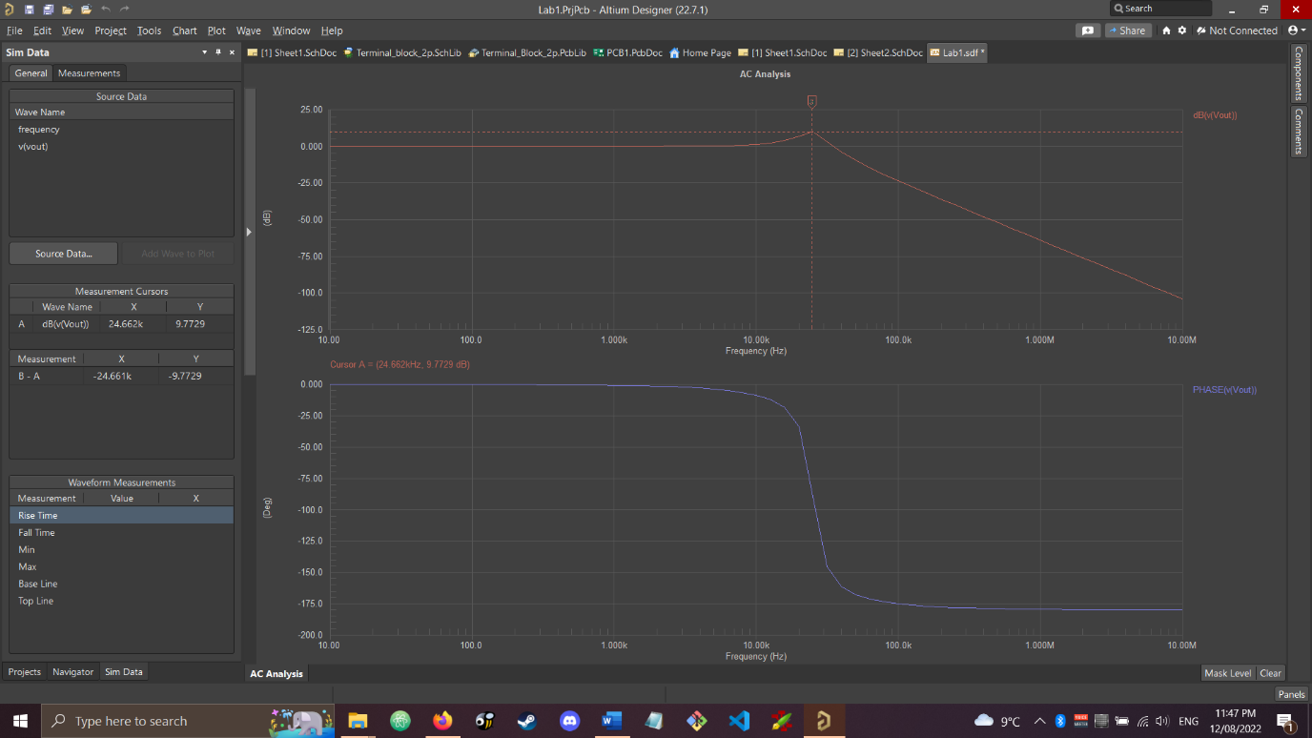

Figure 10: AC Sweep analysis of the RLC circuit

From the cursor on this plot it was found that the circuit has a resonant frequency of 25.12 kHz, which matches the theoretical value.

# Conclusion

In conclusion the simulations in Altium designer were both a success as the simulated outputs closely matched the theoretical calculated values. A good way to verify the result further would be to use real components and a physical circuit analysis tool, such as an oscilloscope, to find the output waveforms of each circuit.